
Hong Kong Association of University Women

*Undergraduate / Postgraduate Scholarship 2023

(*Please delete whichever is not applicable)

Application Form

Complete this form in BLOCK LETTERS. Please read the Scholarship Application Details carefully before filling this form. Completed form together with all required documents must be received by HKAUW by 5:00 p.m. on 29th October 2023 via the Student Affairs Office of the applicant’s institution. HKAUW WILL NOT CONSIDER ANY LATE APPLICATION.

- Personal Particulars | Please attach a recent photo for identification purpose

Family Name, Given Name: |  | Chinese Name (if available):
Date of birth and Age: |  | Nationality and HKID No. / Passport No.:
Correspondence Address: |  | E-mail address:
 |  | (Private)
 |  | (Institution)
Office/Home Phone Number: |  | Mobile Phone Number:
Name of Institution: |  | Degree Pursuing:
Programme Title: |  | Year of Study:

- Academic performance and academic & non-academic award(s) obtained (Scholarships, Prizes, Honors and Awards won at University level or above):
 | a. | Academic records (please attach copies of relevant academic transcripts and certificates from tertiary level):
 |  | Cumulative GPA: ________________

 | b. | Academic award(s) obtained (copy of certificate(s) required):
 |  | Year |  | Academic award(s) obtained (including amount if cash awards are involved)

 | c. | Non-academic awards(s) obtained (copy of certificate(s) required):
 |  | Year |  | Non-Academic award(s) obtained (including amount if cash awards are involved)

___________ ________________________________________________________________________________________

- Details of professional activities and community service you have taken part in the past 5 years which have bearing on the application (in descending chronological order).

 | Year |  | Name of organization/Position held |  | Nature of services/attainment

_______________ ____________________________________________ __________________________________________

IV. | Other additional information which may have bearing on the application

( Please attach additional pages to the application as needed.)

Referee
Please give the name, job title, correspondence address, daytime telephone and e-mail address of the two referees after you have obtained her/his consent. Your referees should have knowledge of your current work and should be able to comment on your academic achievements and your contribution to your field and the community.

1.
2.

Declaration by the Applicant (Please check the boxes where applicable)

□ I have checked and ensured that all necessary enclosures, including copies of certificates and documents have accompanied this application. I declare that the information I have provided in this application and in its accompanying documents are, to the best of my belief, complete and correct. I attach ______ sheets of supplementary information.

□ I hereby authorize the information provided in this application to be seen by all the persons who are involved in the assessment of the application including specialists in the same field, and in case I am to receive this scholarship, that such will continue be used for purposes related to the award and to membership of the HKAUW.

□ I have completed the Membership Application Form to become a Full Member (for Postgraduate Scholarship applicant)/Undergraduate Member (for Undergraduate Scholarship Applicant) of the Association through the online membership application system.

□ I have paid the membership fee to the HKAUW bank account, and hereby enclose the original transaction receipt as proof of membership fee payment. I have also retained a photocopy of the advice as proof of membership fee payment.

□ I understand that should I fail to provide written evidence of my further community service before 31st August 2024, the 25% remained amount of my scholarship award will be forfeited.

Date : Name :

_________________________________________
Signature

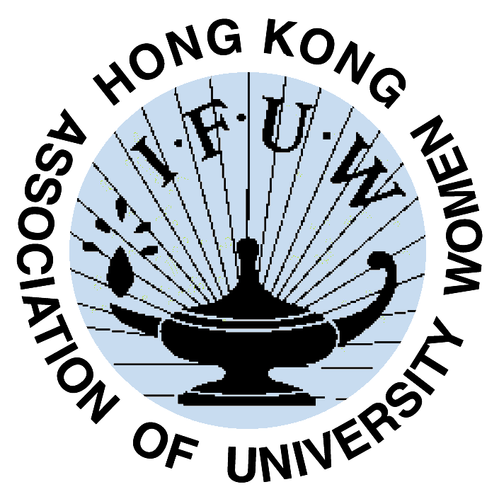
For Office Use Only |  | Signed by
Payment Received Date
Membership No.
Record Enter Date
Hong Kong Association of University Women
Application for Membership

Name in English (Dr / Ms / Mrs / Mr)  (in BLOCK Letter) | Surname Given Name
Name in Chinese (if applicable)
Nationality
Mobile Phone
E-mail Address | Primary Email:  Secondary Email:
University / Employer
Major (if student) / Profession
Attained Degree(s)/ University/ Year
Postal Address
Type of Member | ❑ LIFE Membership HK$3000.00   ANNUAL FULL Membership HK$300.00   ANNUAL ASSOCIATE Membership HK$300.00   ANNUAL Undergraduate Membership HK$150.00
Payment Method | ❑ Bank deposit/ATM transfer (Bank of East Asia, Account No. 015-176-68-00002-2)   Cheque payable to "Hong Kong Association of University Women"  Please send ATM slip or cheque by post to  The Treasurer, HKAUW, G.P.O. Box 11708, Hong Kong.
Additional information, if any, to help us to get to know you more e.g. interests, hobbies etc.

Signature: ________________________________ Date: _______________________

NOTE: Please refer to details under Membership at our website, www.hkauw.org

Personal Data and Privacy Disclaimer:
I agree the above personal data provided to the Hong Kong Association of University Women (HKAUW) would be updated in the database maintained by HKAUW and used for HKAUW contact with me and promotion of latest news (including any events and functions to be held, courses to be organized, solicitation of donations, discount, benefit and service offers, and other related activities). If you wish to unsubscribe HKAUW news or change personal data, please send email to info@hkauw.org.

